Sn Na Ag S Thermoelectric Validation
Detailed report for Sn0.96Na0.01Ag0.03S
Prepared from the supplied papers, source datasets, project code, model outputs and external verification records. Measured values, formula checks and model extrapolations are labelled separately.

Executive summary
The supplied Nature Communications paper and Figshare source files were converted into a reproducible validation and modelling workflow. The central result is reproduced from the source data: Sn0.96Na0.01Ag0.03S reaches zT = 1.058 at 300 K and zT = 1.997 at 573 K. The available table ends at 573 K, so there is no direct 600 K measurement. ExtraTrees is the strongest conservative model under composition-grouped validation, but the dataset is too small to support a general discovery claim.
Item | Result | Interpretation
Target | Sn0.96Na0.01Ag0.03S | x = 0.03 in Sn0.99-xNa0.01AgxS
Source rows | 35 | Five compositions x seven temperatures
Measured range | 300, 323, 373, 423, 473, 523, 573 K | No 600 K row
Formula residuals | PF <= 0.0167%; zT <= 0.0808% | Spreadsheet-rounding level
Best grouped-CV model | ExtraTrees: MAE 0.171, RMSE 0.198, R2 0.779 | Corrected composition features
Peak target zT | 1.997 at 573 K | Measured source / formula reconstruction

Scope and evidence boundaries
The papers supply experimental methods, equations, composition labels and reported transport results. The models and candidate interpretations were implemented in the project code. A model estimate is never presented as an exact measurement, and a formula check is not an independent experiment.

Source paper and doping design
The paper studies substitutional co-doping in Sn0.99-xNa0.01AgxS with x = 0, 0.01, 0.02, 0.03 and 0.04. Na is held at 1 at.% while Ag is varied on the Sn site. The reported interpretation is that Na adjusts carrier concentration and Ag modifies band structure and lattice dynamics, supported by structural and spectroscopic characterization.
The synthesis route is a modified Bridgman process: high-purity precursors are loaded into carbon-coated quartz under approximately 50 mTorr, annealed at 1273 K for three days, crushed and sieved, remelted, and directionally cooled at about 1 K per hour over roughly 14 days. The paper defines kappa_total = D Cp rho, kappa_e = L sigma T and kappa_l = kappa_total - kappa_e.

Dataset inventory and what was used
The supplied Figshare record contains figure-level XLSX exports, ZIP archives and POSCAR structures. The modelling table uses the common rectangular tables from Figure 2a-d and Figure 8a: Seebeck coefficient, electrical conductivity, power factor, total thermal conductivity and published zT. The normalized table contains five compositions and seven temperatures, for 35 rows. Central values were parsed from strings containing plus or minus uncertainty; uncertainty text was not used as a feature.
Input | Used | Reason
Figure 2a Seebeck | Yes | S in microV/K
Figure 2b conductivity | Yes | sigma in S/cm
Figure 2c power factor | Yes | PF in microW cm-1 K-2
Figure 2d thermal conductivity | Yes | kappa_total in W/mK
Figure 8a zT | Yes | Target for reproduction
POSCAR supercells | Inventory only | Two structures do not represent 35 rows
Alternate DSC / uncertainty tables | Kept separate | Not complete composition-by-temperature tables

Formula calculations and unit checks
For workbook units, PF = S^2 sigma x 10^-6 in microW cm-1 K-2. SI zT is zT = PF x 10^-4 x T / kappa_total, with T in kelvin and kappa_total in W m-1 K-1. Across all 35 rows, the maximum relative PF residual is 0.0167% and the maximum zT residual is 0.0808%, consistent with spreadsheet rounding.
T (K) | S | sigma | PF | kappa total | kappa lattice | source zT | recomputed zT
300 | 243.80 | 1697.47 | 100.89 | 2.862 | 1.890 | 1.058 | 1.05755
323 | 249.17 | 1508.59 | 93.66 | 2.677 | 1.750 | 1.130 | 1.13008
373 | 266.85 | 1145.64 | 81.58 | 2.248 | 1.439 | 1.354 | 1.35362
423 | 285.93 | 892.56 | 72.97 | 1.836 | 1.124 | 1.681 | 1.68117
473 | 298.47 | 680.49 | 60.62 | 1.556 | 0.951 | 1.843 | 1.84275
523 | 317.18 | 499.12 | 50.21 | 1.330 | 0.841 | 1.974 | 1.97442
573 | 334.80 | 359.82 | 40.33 | 1.157 | 0.771 | 1.997 | 1.99733

Data errors found and fixes applied
- Mixed source tables were separated so alternate DSC and uncertainty entries were not merged into the primary table.
- PF is in microW cm-1 K-2 while zT requires W m-1 K-2; explicit 10^-6 and 10^-4 conversions were added and checked.
- Plus-or-minus strings were parsed to central values, preventing uncertainty text from becoming a second measurement.
- The random row split was replaced by GroupKFold by composition to prevent temperature-row leakage.
- A chemistry-feature bug was found in the first code version: it set Na_at_frac = x even though Na is fixed at 0.01 in the paper. The code now uses Na_at_frac = 0.01, Ag_at_frac = x and Sn_at_frac = 0.99 - x, then regenerates metrics and plots.
- The missing 600 K source row is reported explicitly; no 600 K measurement was invented.
- The two POSCAR files are inventoried but not treated as atomistic features for all transport rows.

Feature engineering and feature selection
The leakage-controlled feature matrix uses temperature, nominal x, fixed Na fraction, Ag fraction, Sn fraction and formula mass. Measured S, sigma, PF, kappa and zT are excluded. Ridge uses SelectKBest with k = 3 inside each training fold. After the chemistry correction, descriptive all-data ExtraTrees importance is temperature 0.520, Ag fraction 0.135, x 0.125, formula mass 0.113, Sn fraction 0.107 and fixed Na fraction 0.000. Correlated composition variables make these predictive attributions rather than causal doping effects.

Models and cross-validation
The primary evaluation is five-fold GroupKFold by composition, so all seven temperatures from one held-out composition remain unseen. Repeated random K-fold is retained only as a sensitivity analysis. Models tested were a mean baseline, Ridge with in-fold feature selection, Random Forest, Gradient Boosting and ExtraTrees.
Model | MAE | RMSE | R2 | Assessment
Mean baseline | 0.392 | 0.469 | -0.245 | Reference
Ridge + selection | 0.236 | 0.326 | 0.398 | Linear baseline
Random Forest | 0.231 | 0.255 | 0.632 | Tree baseline
Gradient Boosting | 0.225 | 0.243 | 0.666 | Nonlinear baseline
ExtraTrees | 0.171 | 0.198 | 0.779 | Best grouped-CV model

Where the model was right and where it failed
ExtraTrees correctly captured the broad increase of zT with temperature and ranked best under composition-held-out validation. After the chemistry-feature correction, when x = 0.03 was held out it underpredicted all target points: about 0.925 versus 1.058 at 300 K, 1.362 versus 1.681 at 423 K, and 1.648 versus 1.997 at 573 K. Only five composition groups exist; removing one removes the whole target trajectory. Nonlinear transport, correlated composition variables and regression toward the training mean explain the bias. The 573 K point is also near the upper edge of the data and does not support a 600 K measurement claim.

Training and testing graphs
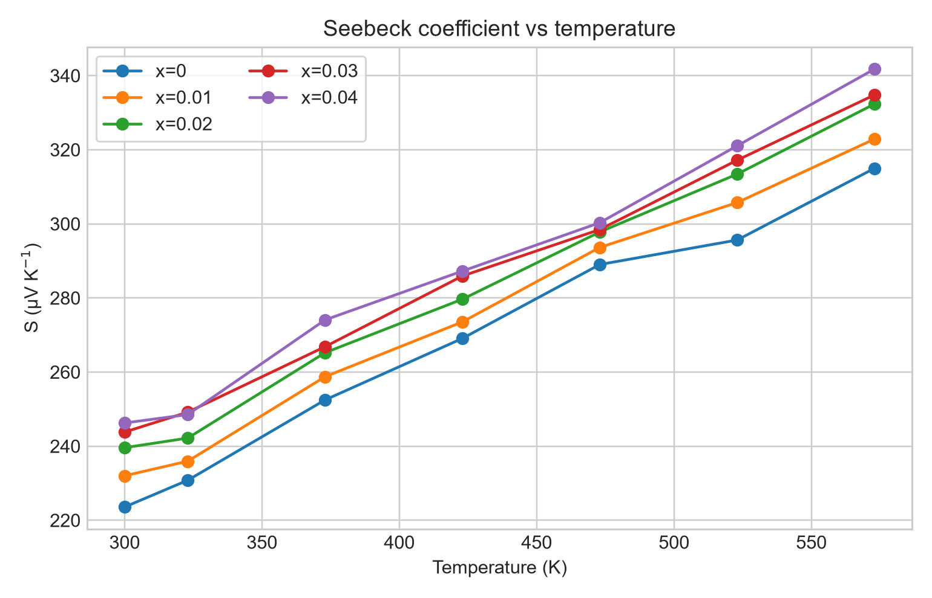
Measured Seebeck coefficient curves.
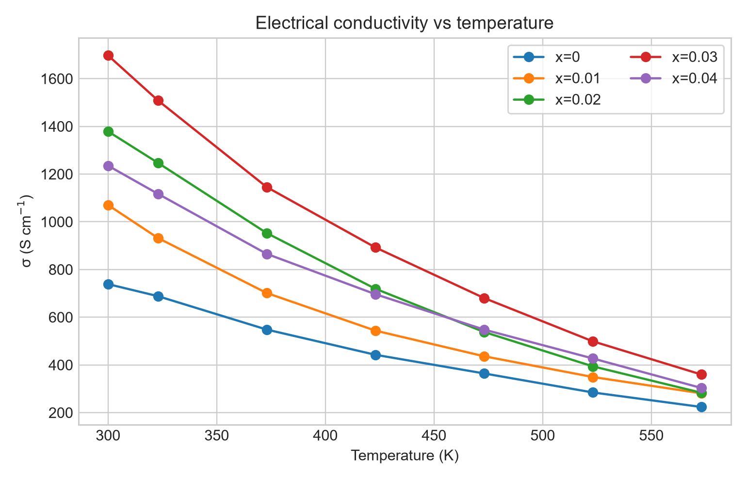
Measured electrical conductivity curves.
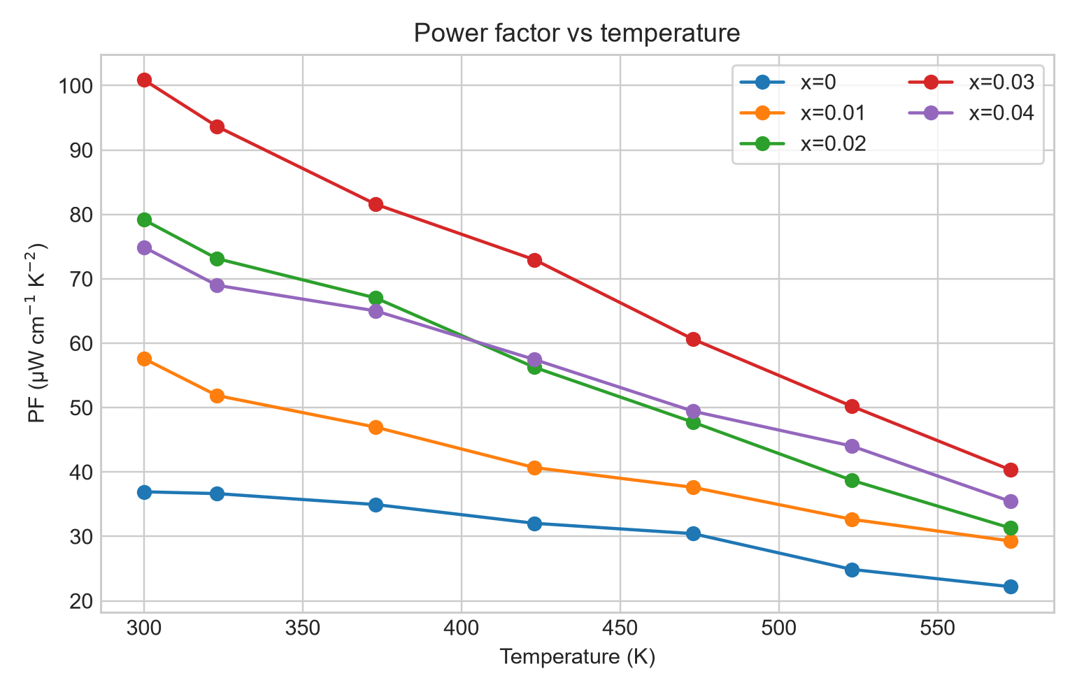
Measured power factor curves; target PF is about 101 microW cm-1 K-2 near 300 K.
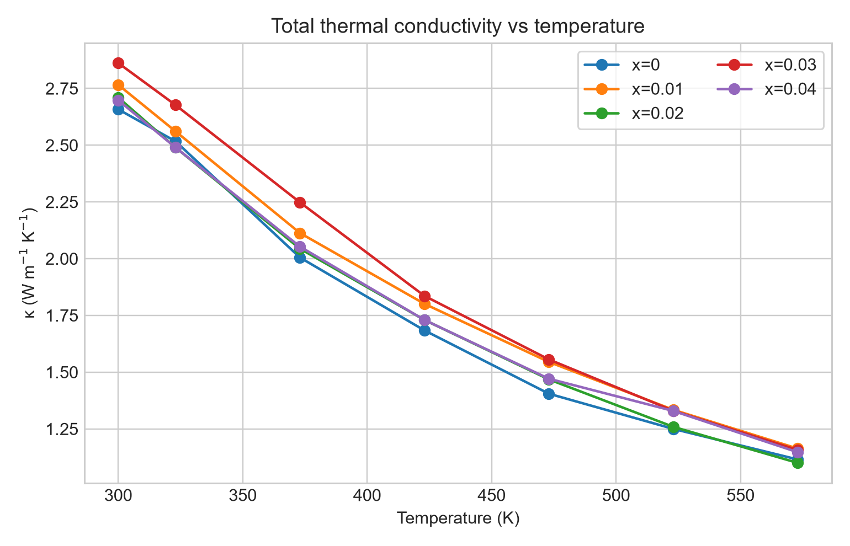
Measured total thermal conductivity curves.
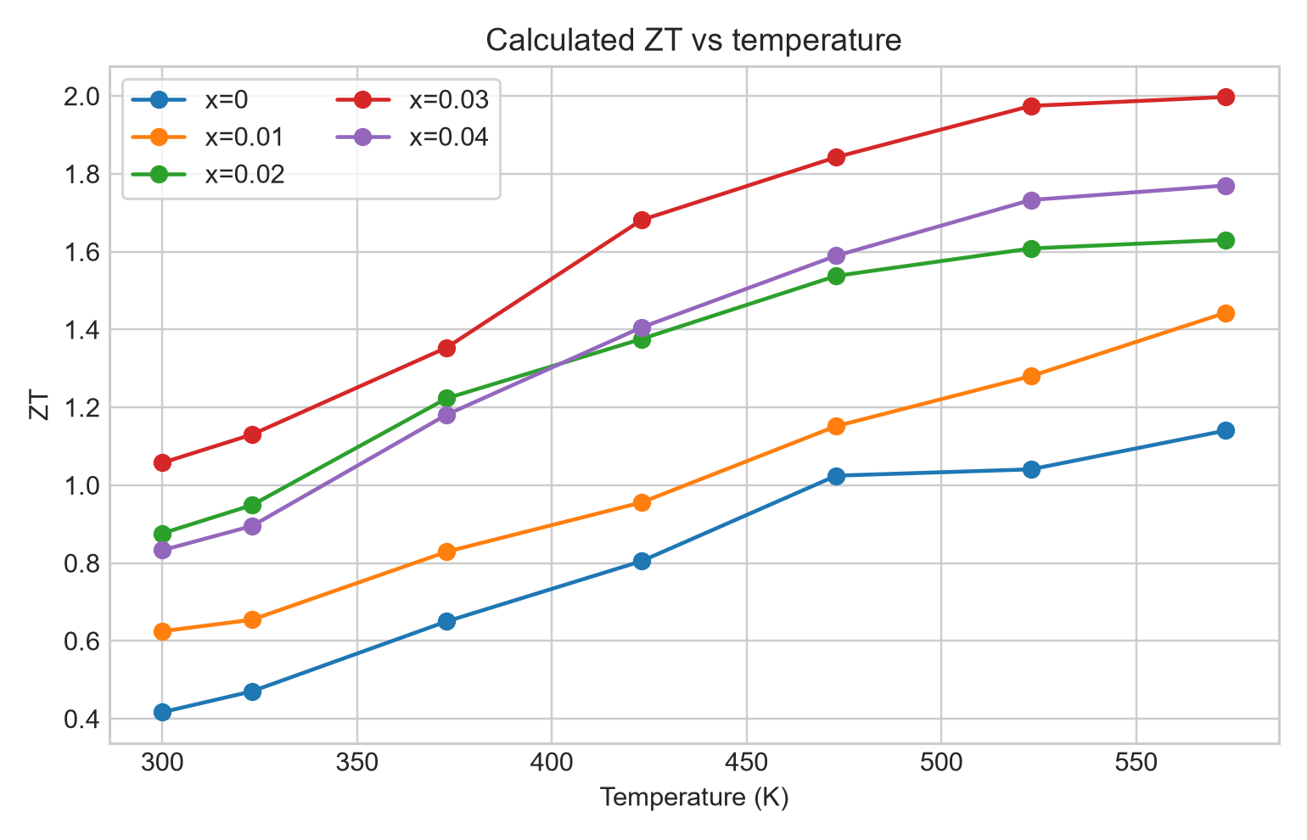
Measured and reconstructed zT curves; target peak near 2 at 573 K.
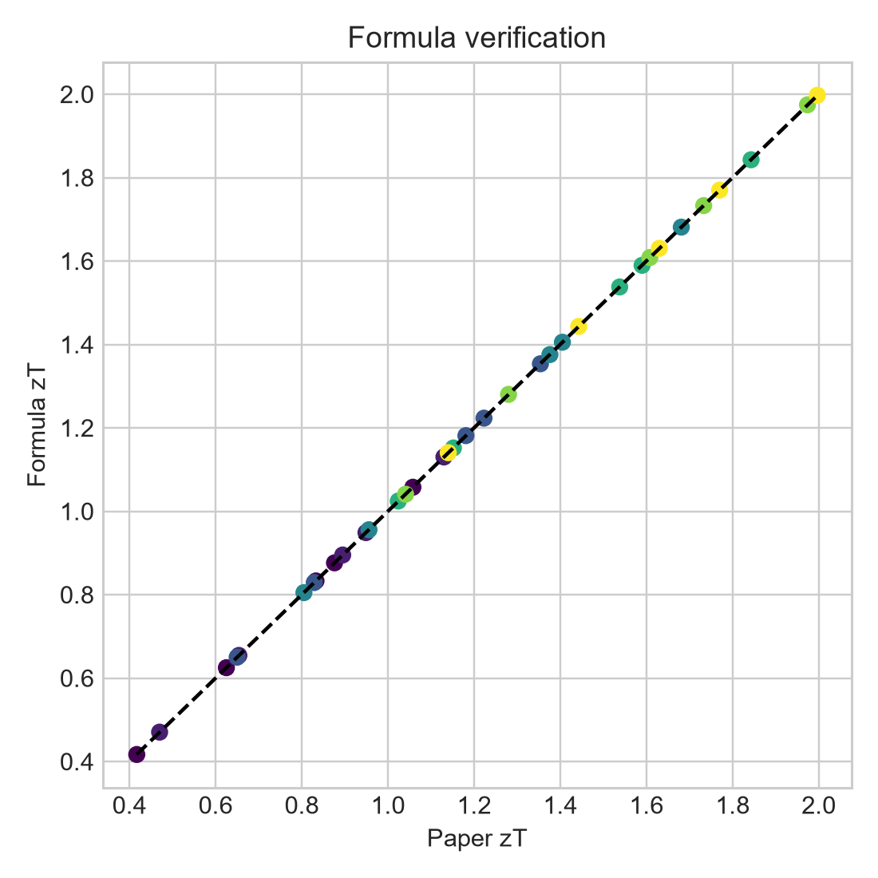
Supplied versus formula-recomputed zT.
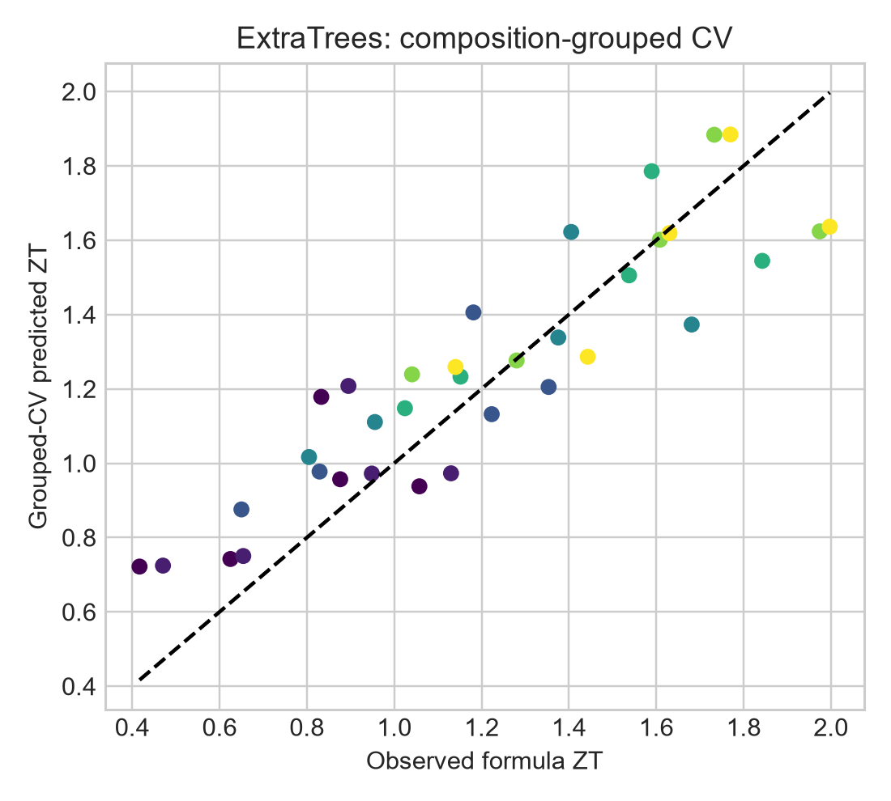
ExtraTrees grouped-CV predicted versus observed zT.
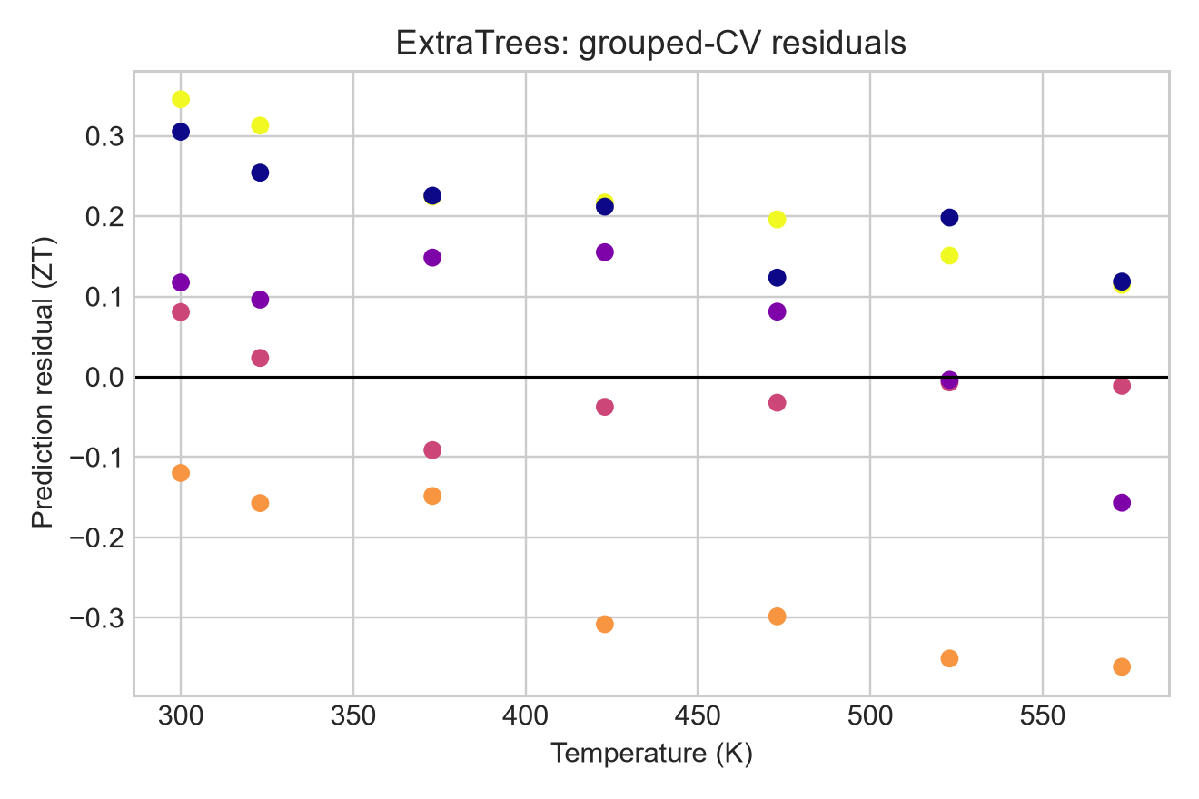
ExtraTrees grouped-CV residuals.
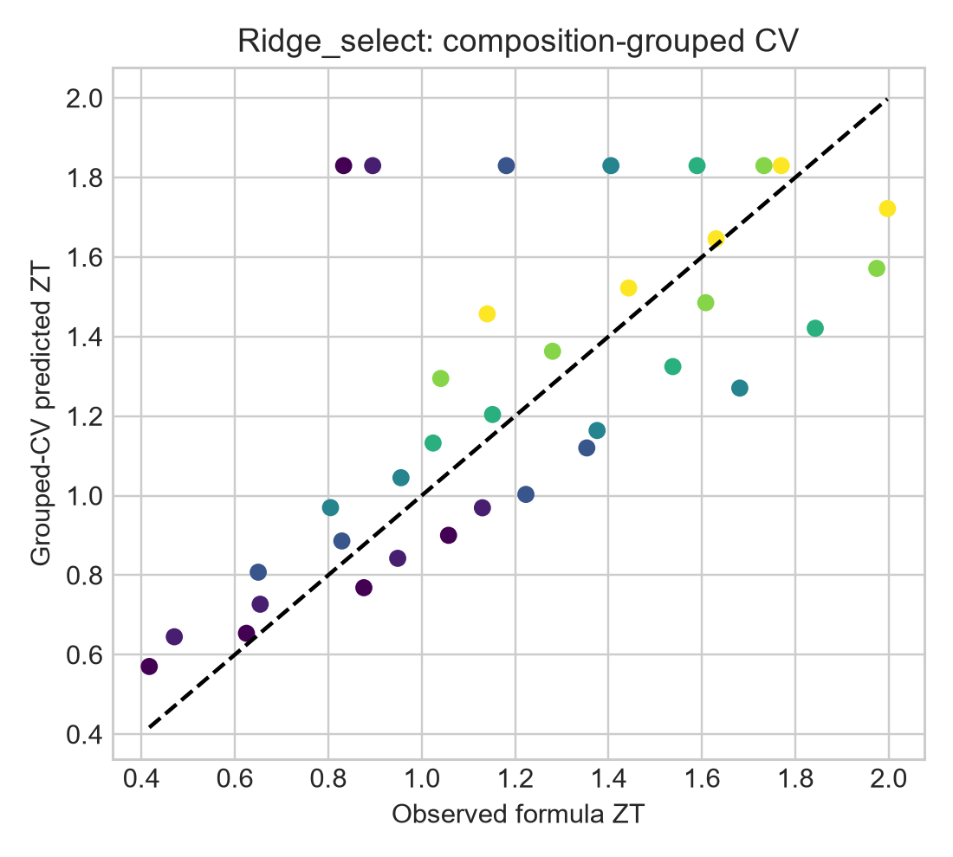
Ridge grouped-CV parity.
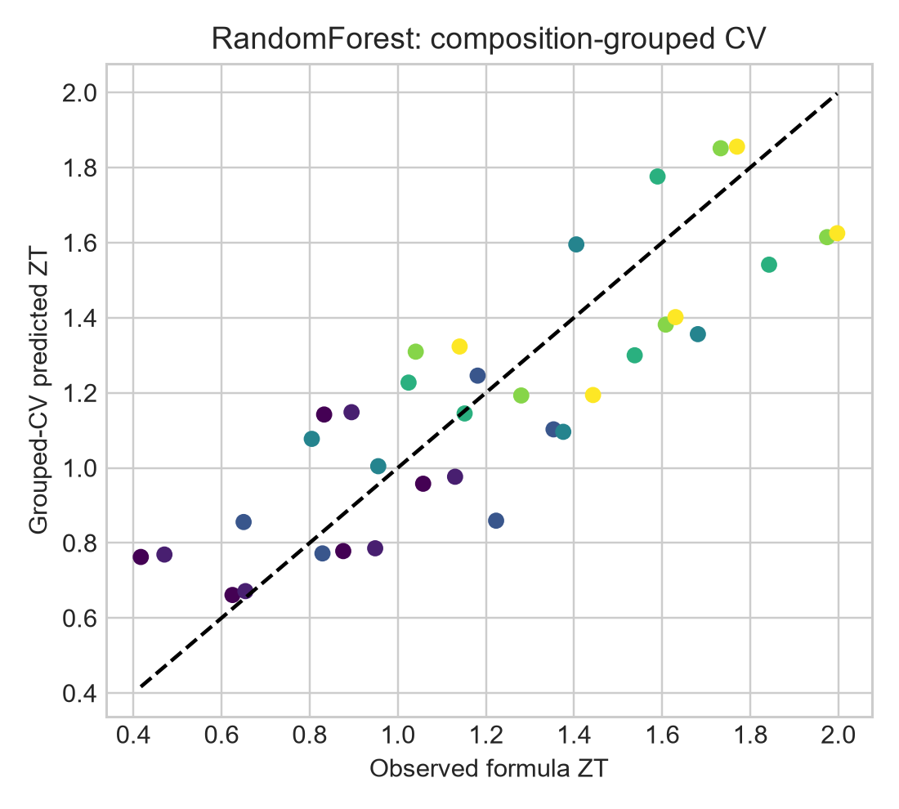
Random Forest grouped-CV parity.
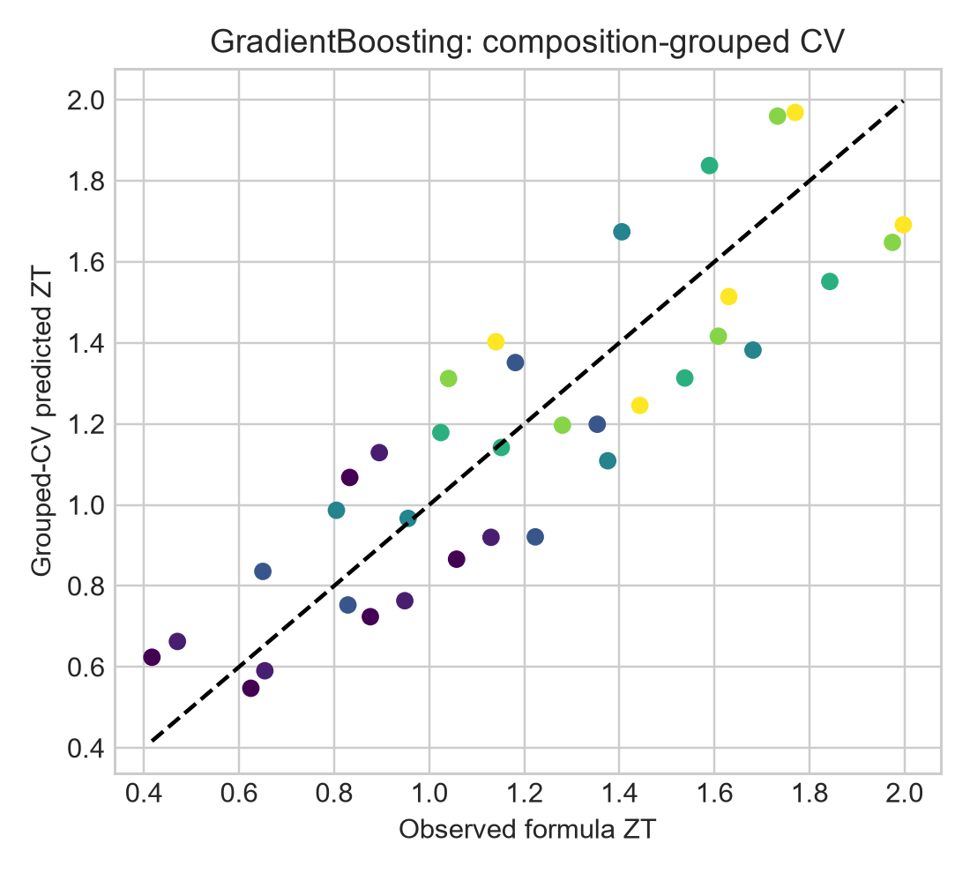
Gradient Boosting grouped-CV parity.

External verification and papers compared
Crossref, the Nature publisher record and the official Figshare API were used to verify article identity, DOI, dataset provenance, composition, synthesis route, equations and headline zT values. Independent literature was context, not a replacement for the supplied measurements.
Reference | Contribution | Use
Nature Communications, DOI 10.1038/s41467-026-77691-x | Primary paper, composition, synthesis, equations, zT | Direct validation source
Figshare 33191598 | Official XLSX, ZIP and POSCAR provenance | Dataset identity
Ag-doped SnS, DOI 10.1016/j.jmat.2019.12.003 | Independent high-temperature benchmark | Context only
Sulfide review, DOI 10.1016/j.jmat.2023.05.011 | Band engineering and phonon scattering | Mechanism context
Na/Ag textured SnS, DOI 10.1016/j.jallcom.2025.179124 | Related publication | No numerical claim; abstract blocked
Bell, DOI 10.1126/science.1158899 | General thermoelectric context | Background only

- Primary article https://doi.org/10.1038/s41467-026-77691-x
- Figshare record https://api.figshare.com/v2/articles/33191598
- Ag-doped SnS benchmark https://doi.org/10.1016/j.jmat.2019.12.003
- Sulfide review https://doi.org/10.1016/j.jmat.2023.05.011
- Related Na/Ag paper https://doi.org/10.1016/j.jallcom.2025.179124

Advantages and limitations

Advantages
- Reproduces PF and zT with sub-0.1% maximum zT residual.
- Uses composition-grouped validation to avoid temperature-row leakage.
- Separates measured data, formula checks, predictions and POSCAR inventory.
- Provides separate plots, normalized tables, diagnostics and runnable code.
- Makes the missing 600 K observation explicit.

Limitations
- Five composition groups and 35 rows give large uncertainty.
- Figure-level exports retain source rounding.
- No new composition is experimentally measured.
- POSCAR files are not used as an atomistic feature model.
- Feature importance is not causal mechanism evidence.
- Values above 573 K would be extrapolations.

GitHub contents and reproducibility
The validated project is published at https://github.com/NischalRaj16/sn-na-ag-thermoelectric-validation. It contains project/src, normalized data and checks under project/outputs/tables, separate PNG figures under project/outputs/plots, paper and dataset audit notes, and a README. Run from the project folder:
python src/run_analysis.py --data-dir "C:\Users\kraj8\Dropbox\Ms thesis\Research paper\Datasets\33191598" --out-dir outputs

Conclusion
For Sn0.96Na0.01Ag0.03S, the measured and formula-recomputed result is zT about 1.06 at 300 K and about 2.00 at 573 K. The model captures the broad trend but is biased low for the held-out target because there are too few independent compositions. The defensible result is validated reproduction and transparent small-data modelling, not a new experimental optimum.

